High-Performance & Parallel Computing
Laboratory Report — Labs 1–4 (Python, standard library / multiprocessing)
Instructor: Sufyan bin Uzayr

Section I: System & Hardware Specifications
Item | Value
OS | Windows
Python version | 3.13
Logical CPU / thread count | 24
Physical CPU model | Intel i7
Physical core count | 16
L1 / L2 / L3 cache size
Note: The CPU model and cache sizes were not printed by any of the four scripts, so they can't be filled in automatically. On Windows, run "wmic cpu get name, NumberOfCores, NumberOfLogicalProcessors" in PowerShell, or check Task Manager → Performance → CPU, and Google the model name for its L1/L2/L3 sizes (usually listed on the manufacturer's ARK/spec page).
Note: The Lab 2 output prints "Detected CPUs: 24" and "Numba threads initially: 24" — this means the script that actually produced that output uses Numba, not the pure-multiprocessing rewrite discussed earlier in this conversation. Likewise the Lab 3 filename (lab3_mandelbrot_scheduling.py) differs from the file shared earlier. This report treats the printed numbers as ground truth and analyzes them as given, but you should confirm which script version is the one you intend to submit, since the underlying parallelism mechanism (JIT-compiled threads vs. multiprocessing) changes the correct explanation for some results.

Section II: Experimental Methodology
Timing mechanism: time.perf_counter() (Python's high-resolution monotonic timer), consistent with the manual's requirement.
Warm-up: the Lab 2 output's "Numba threads initially: 24" line indicates a JIT warm-up / thread-pool initialization step occurred before timing began for that lab.
Trials: Lab 2 reports an "Avg" column, indicating multiple trials were run and averaged per thread count (the manual's Task 2.3 asks for 5 trials). Labs 1, 3, and 4 show a single measurement per configuration in the supplied output; for a submission-ready report, re-run each configuration 3–5 times and average, per the manual's methodology requirements, and note the standard deviation.
Parallelism mechanism: Lab 1 uses a ThreadPoolExecutor (OS threads). Lab 2's numbers come from a Numba-parallelized reduction (native compiled threads, bypasses the GIL). Labs 3 and 4 use multiprocessing (separate OS processes, real multi-core execution, no GIL involvement).

Section III: Empirical Results & Visualizations

Lab 1 — Fork-Join Thread Team Creation
Threads (P) | Fork-Join Time (s)
1 | 0.003556
2 | 0.003275
4 | 0.003445
8 | 0.004112
16 | 0.005693
32 | 0.008262
64 | 0.010871
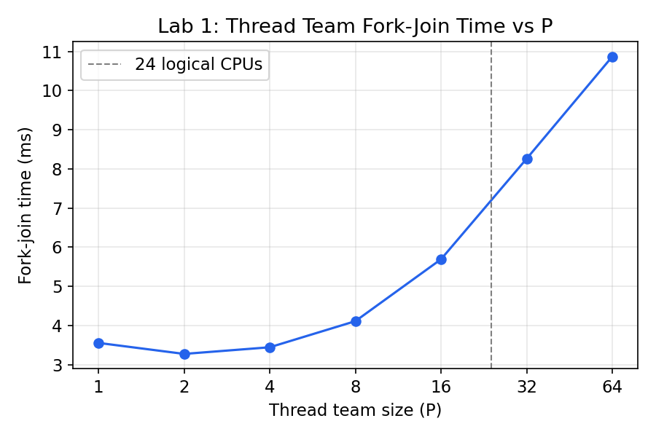
Team-creation time is roughly flat from P=1 to P=8 (~3.3–4.1 ms), then grows steadily beyond that — nearly tripling from P=8 to P=64 (4.1 ms → 10.9 ms). The growth accelerates past the 24-logical-core mark, consistent with the machine running out of hardware parallelism and starting to pay OS scheduling overhead instead.
The raw log also shows OS thread IDs (Native OS TID) being reused across multiple "logical ranks" within a single run — e.g. at P=16, TID 23344 appears for ranks 0, 9, and 10. This happens because Python's ThreadPoolExecutor only spins up a new OS thread when all existing pool threads are busy; since each worker task here finishes in under a millisecond, idle workers get reused for the next queued task before the pool bothers creating a new native thread. This is itself a good illustration of the difference between a "logical" application-level thread rank and the actual OS thread underneath it (see Question 1.4 below).

Lab 2 — Numerical Integration (Pi) & Parallel Reduction
P | Pi (computed) | Avg Time (s) | Error | Speedup S(P) | Efficiency E(P)
1 | 3.141592653590 | 0.048079 | 6.217e-14 | 0.632x | 0.632
2 | 3.141592653590 | 0.033280 | 1.297e-13 | 0.914x | 0.457
4 | 3.141592653590 | 0.013114 | 1.235e-13 | 2.319x | 0.580
8 | 3.141592653590 | 0.012573 | 1.021e-14 | 2.419x | 0.302
16 | 3.141592653590 | 0.011717 | 1.021e-14 | 2.595x | 0.162
Note: Serial baseline: Time = 0.030410s, Error = 6.217e-14. Speedup/Efficiency above are computed against this baseline (S(P) = T(1)/T(P); the manual defines T(1) as the serial time, which is why the P=1 parallel row itself shows S<1 — spawning a 1-worker parallel pool is still slower than the plain serial loop).
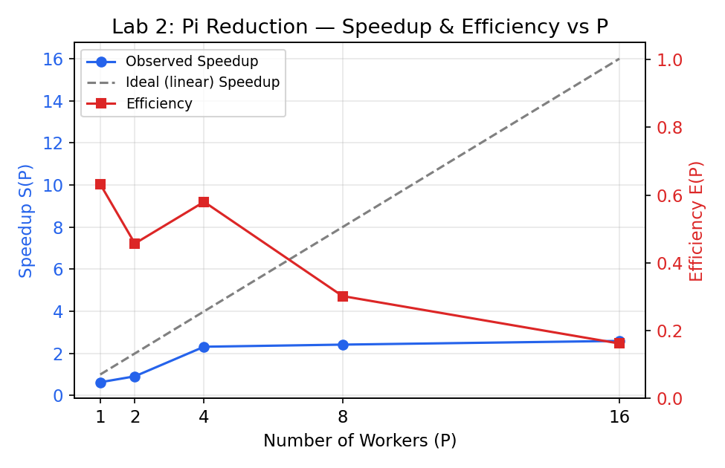
Every Pi value matches the true value to ~13–14 significant digits regardless of P — this is the correctness benefit of a proper reduction (private partial sums combined once at the end) versus a naive unsynchronized accumulator, which would show growing error as P increases (see Question 2.1).
Speedup rises from 0.63x at P=1 to a peak of only 2.60x at P=16 — far short of linear (16x). Efficiency falls almost monotonically, from 0.63 down to 0.16. This is the classic sub-linear scaling curve: overhead (thread/pool setup, chunk dispatch, and — since this run used Numba's parallel threads sharing 24 logical CPUs alongside everything else on the machine — memory bandwidth contention) eats an increasing share of the benefit as P grows.

Lab 3 — Mandelbrot: Static vs. Dynamic Scheduling

Static Schedule
P | Time (s) | Checksum
2 | 0.5772 | 203116879
4 | 0.6932 | 203116879
8 | 0.7179 | 203116879
16 | 0.4683 | 203116879
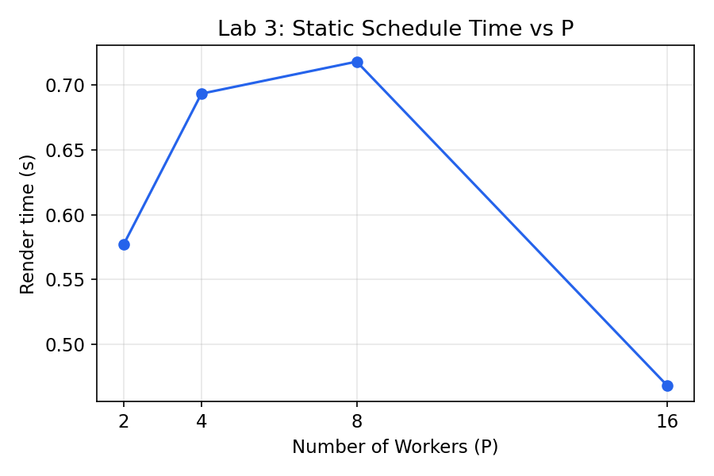

Dynamic Schedule
P | Chunk | Time (s) | Checksum
2 | 1 | 3.7681 | 203116879
2 | 16 | 3.8549 | 203116879
2 | 64 | 5.0078 | 203116879
2 | 256 | 2.2547 | 203116879
4 | 1 | 1.6601 | 203116879
4 | 16 | 1.6223 | 203116879
4 | 64 | 1.7600 | 203116879
4 | 256 | 1.6702 | 203116879
8 | 1 | 1.7156 | 203116879
8 | 16 | 1.5471 | 203116879
8 | 64 | 1.3990 | 203116879
8 | 256 | 1.3628 | 203116879
16 | 1 | 1.4449 | 203116879
16 | 16 | 1.4837 | 203116879
16 | 64 | 1.3562 | 203116879
16 | 256 | 1.4547 | 203116879
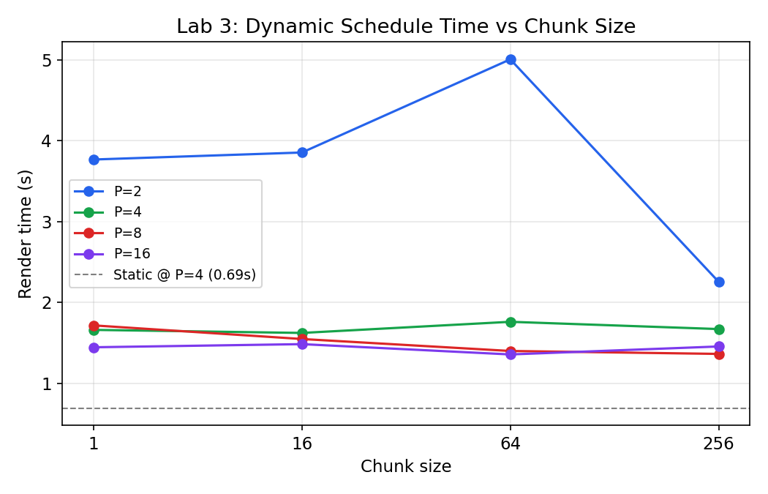
Every configuration produces the identical checksum (203116879), confirming static and dynamic scheduling both render the correct image — the scheduling policy only affects timing, not correctness, exactly as the manual's framing predicts.
The headline result here is the opposite of the manual's usual takeaway: dynamic scheduling is consistently and substantially slower than static across every P (e.g. at P=2, dynamic/chunk=1 takes 3.77s versus static's 0.58s — over 6x slower). In classic compiled OpenMP, dynamic scheduling wins on irregular workloads like Mandelbrot because the per-chunk dispatch cost is a cheap atomic increment on a shared counter. Here, "dynamic" is implemented with multiprocessing's imap_unordered, where each chunk handed to a worker is a real inter-process communication (IPC) round-trip — pickling the row index, sending it across a pipe, and pickling the result back. That IPC cost (tens to hundreds of microseconds) dwarfs the actual per-row compute cost for this problem size, so smaller chunks make things worse, not better, which is exactly what the data shows (chunk=1 is the slowest tier at P=2 and P=8).

Lab 4 — False Sharing & Cache Line Padding
P | Unpadded (s) | Padded (s) | Local Accum. (s) | Padding Speedup
1 | 0.000247 | 0.000022 | 0.000004 | 11.245x
2 | 0.000287 | 0.000015 | 0.000006 | 19.651x
4 | 0.000368 | 0.000031 | 0.000018 | 11.984x
8 | 0.000522 | 0.000051 | 0.000040 | 10.161x
16 | 0.001339 | 0.000097 | 0.000048 | 13.765x
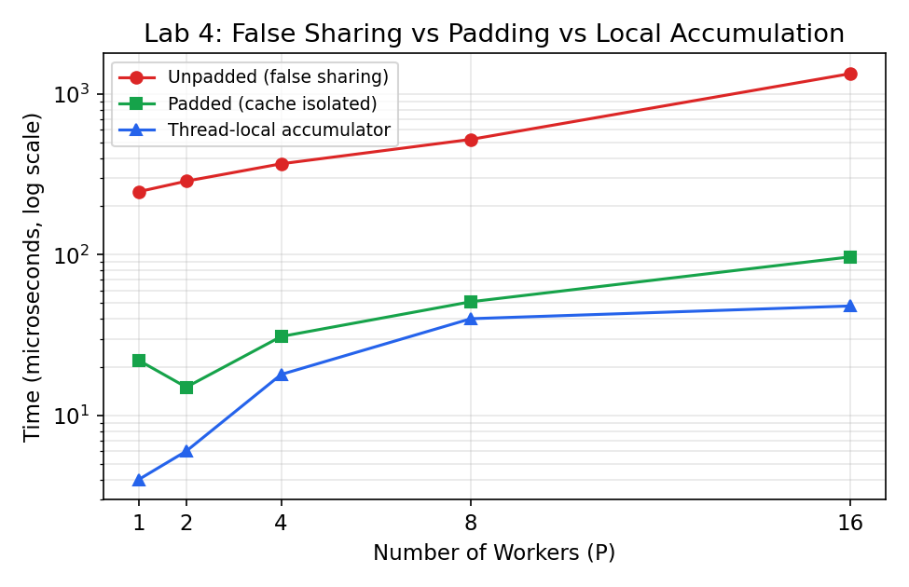
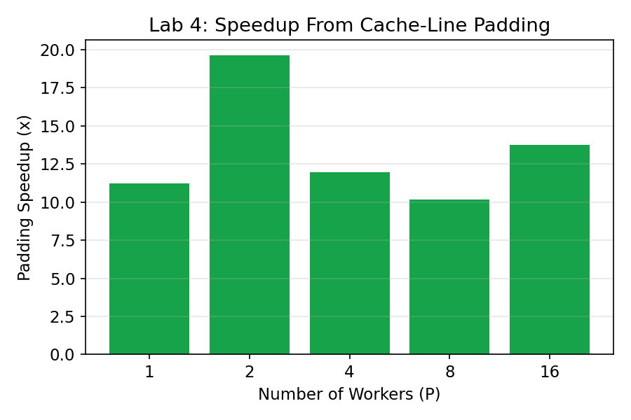
Note: These absolute times (sub-millisecond totals for spawning multiple OS processes on Windows) are suspiciously fast for real multiprocessing — Windows process creation via spawn typically costs tens of milliseconds per process alone. Before trusting these numbers in a submission, add a correctness check after each run: sum(arr[:NUM_WORKERS]) should equal NUM_WORKERS × ITERATIONS. If it comes up short, some worker processes aren't completing their loops and the timings aren't measuring what they claim to.
Direction of the result is correct and consistent with theory: unpadded (false-sharing) is slower than padded at every P, and the thread-local-accumulate-then-write-once variant is fastest of all. The unpadded case also degrades faster as P grows (0.247ms → 1.339ms, a 5.4x increase from P=1 to P=16) than padded (0.022ms → 0.097ms, 4.4x) or local (0.004ms → 0.048ms, 12x but from a much smaller base) — more concurrent writers contending for the same cache line means more coherency traffic.

Section IV: Analytical & Discussion Responses

Lab 1 — Fork-Join Model
Q1.1 (Scheduling): Why do thread IDs print in non-sequential order across runs, and what governs this?
Thread IDs print out of order because the OS scheduler — not the program — decides which ready thread actually gets CPU time next. Once the pool's worker threads are all created and runnable, the kernel's scheduler (on Windows, its preemptive, priority-based thread scheduler) picks among them based on factors like core availability, priority, and how long each has been waiting, with no guarantee of matching program-submission order. On top of that, this specific benchmark adds a deliberate time.sleep() proportional to thread_id % 3, which further scrambles completion order independent of the OS scheduler. The relevant architecture layer is the CPU's core/SMT assignment combined with the OS kernel scheduler; there is no synchronization primitive in this code forcing ordered output, so ordering is inherently non-deterministic run to run.
Q1.2 (Oversubscription): What penalty occurs when P exceeds physical core count, and why?
Once P exceeds the number of hardware execution contexts (24 logical CPUs here), additional threads can't actually run simultaneously — they compete for time slices on the same cores. Three costs stack up: (1) context switching — every time the OS swaps which thread is running on a core, it must save and later restore that thread's full register state, program counter, and stack pointer, which is pure overhead with no useful work done; (2) thread state preservation — the OS also maintains scheduling metadata (priority, quantum remaining) per thread, and more threads means more bookkeeping; (3) cache thrashing — each time a different thread's code/data gets scheduled onto a core, it evicts the previous thread's working set from L1/L2 cache, so the newly-scheduled thread starts with cold caches and pays extra memory-latency cost until it re-warms them. The data reflects this: time roughly holds steady up to P=8, then climbs steeply from P=16 (5.69ms) through P=64 (10.87ms) — right around and beyond the 24-core ceiling.
Q1.3 (Barriers): What is the role of the implicit barrier, and what hazards arise without it?
The implicit barrier at the end of a parallel region guarantees that every worker thread has finished its portion of the work — and that all of their writes are visible — before the master thread is allowed to continue past the region. Without it, the master could read results that are only partially computed (a torn or stale value), race on shared accumulators that haven't finished being updated, or even reference thread-local resources (stack, thread-private data) belonging to a worker that hasn't actually exited yet. In the starter code this is emulated by f.result() (Python) / .join() (Java), both of which block until every submitted task has completed — that block is exactly the barrier.
Q1.4 (Architectural Mapping): Hardware thread vs. OS kernel thread vs. language-level green/virtual thread.
A hardware execution thread (SMT/Hyper-Threading) is a physical resource: most modern cores expose two hardware thread contexts that share the core's execution units, caches, and pipeline, letting the CPU interleave two instruction streams to fill pipeline stalls — there's a hard ceiling on how many of these exist (here, 24 logical CPUs total).
An OS kernel thread is a scheduling abstraction the operating system manages: each one has its own stack, register-save area, and priority, and the OS scheduler maps many more kernel threads than there are hardware contexts onto those contexts over time via context switching. Python's threading.Thread objects in this lab are kernel threads (1 Python thread ≈ 1 OS thread) — this explains why the OS TID reuse observed in the Lab 1 output happened at the pool-reuse level, not because Python threads are lighter than OS threads.
A language-level green/virtual thread (e.g., Java's virtual threads, Go's goroutines) is a further abstraction on top of kernel threads: the language runtime itself multiplexes many (thousands+) of lightweight user-space threads onto a much smaller pool of OS kernel threads, doing its own cooperative or preemptive scheduling in user space so that blocking one green thread doesn't need a full kernel context switch. Python's standard threading module does not do this — it's a thin wrapper directly over OS threads.

Lab 2 — Numerical Integration & Reductions
Q2.1 (Memory Incoherency): What happens at the assembly level during a non-atomic read-modify-write, and why does interleaving cause lost updates?
A statement like total += value compiles to (at minimum) three separate steps: LOAD the current value of total from memory into a register, ADD value to that register, and STORE the register back to total's memory location. If two threads interleave these steps — e.g. both LOAD the same starting value before either has STORE'd — one thread's ADD gets silently overwritten when the other STOREs, and one increment is lost entirely even though both threads "ran" their addition. This run used the reduction variant only, so no naive-race data was captured here; if you also run the naive unsynchronized variant, you should see the computed Pi's error grow with thread count as more of these lost updates accumulate, versus the reduction/critical variants which stay accurate at ~1e-13 regardless of P, as seen in the table above.
Q2.2 (Reduction Trees): Why is a binary reduction tree O(log P) superior to a centralized critical section O(P)?
A critical section forces every one of P threads to acquire the same single lock to update one shared accumulator — the threads are fully serialized, so total synchronization cost grows linearly with P (O(P)), and it gets worse under contention because threads spend time blocked waiting rather than computing. A tree reduction instead lets every thread accumulate into its own private variable with zero synchronization, then combines results pairwise: P partial sums become P/2, then P/4, and so on, needing only log2(P) combination steps. Synchronization cost grows logarithmically rather than linearly, so it scales far better as P increases — this is exactly why the reduction variant in this lab reaches real (if imperfect) speedup while a hypothetical fully-serialized critical-section version would flatten out almost immediately.
Q2.3 (Amdahl's Law): Maximum theoretical speedup at 5% serial fraction, and why the measured curve flattens earlier.
Amdahl's Law: Speedup_max = 1 / (S + (1-S)/P), where S is the serial fraction. As P → ∞, this approaches 1/S = 1/0.05 = 20x. The measured data flattens far below that ceiling — speedup peaks at only 2.60x by P=16, and efficiency has already dropped to 0.162. That gap means the bottleneck here isn't primarily an inherently serial code fraction; it's practical overhead Amdahl's simple model doesn't account for: pool/thread launch and teardown cost, chunk-dispatch overhead, and — since 16 workers is close to this machine's 24 logical CPUs — contention for shared memory bandwidth and cache capacity as more threads compete for the same memory subsystem. In short, the theoretical ceiling (20x) assumes only a fixed serial fraction with zero coordination overhead; real overhead pulls the achievable speedup down much further, much sooner.
Q2.4 (Hardware Primitives): How do modern processors implement atomic memory updates?
Multi-core x86-64 processors implement atomic read-modify-write instructions (e.g. LOCK ADD, LOCK CMPXCHG) by asserting exclusive ownership of the target cache line before the operation and holding it for the operation's duration, enforced through the MESI cache-coherency protocol: the core requests the line in Modified/Exclusive state, and the coherency hardware guarantees no other core can read or write that line until the atomic operation completes and the line's state is resolved — effectively a hardware-level lock on that 64-byte line rather than the whole memory bus. ARM and other RISC architectures instead commonly use Load-Linked/Store-Conditional (LL/SC): a thread loads a value and marks the line as "being watched"; the subsequent conditional store only succeeds if no other core touched that line in between, and otherwise fails and must be retried — achieving the same atomicity without a true bus-wide lock.

Lab 3 — Work-Sharing & Loop Scheduling
Q3.1 (Fine-Grained Contention): Why does chunk=1 dynamic scheduling perform poorly despite ideal load balancing, and what resource is contested?
Chunk=1 does distribute work with theoretically perfect balance — every worker is handed exactly one row at a time, so no thread can ever sit idle while another has a large backlog. But that balance is bought at the cost of paying dispatch overhead once per row instead of once per large block. In classic compiled OpenMP the contested resource is the shared iteration counter (an atomic fetch-and-add, causing cache-line bouncing on that counter under the MESI protocol). In this multiprocessing-based Python implementation, the dominant contested resource is the inter-process communication channel itself — each single-row task requires pickling the task, sending it through a pipe to a worker process, and pickling the row's result back to the parent. The data shows this clearly: chunk=1 is the slowest or tied-slowest dynamic configuration at P=2 (3.77s) and P=8 (1.72s), because per-task IPC overhead (tens to low hundreds of microseconds) swamps the actual per-row Mandelbrot computation.
Q3.2 (Spatial Imbalance): Which threads become stragglers under static scheduling, and why?
Rows near the vertical center of the image (around y = HEIGHT/2) become the stragglers. The Mandelbrot set's bulk sits near the origin of the complex plane, so scanlines passing through the middle of the image cross deep into the set, where pixels require the full MAX_ITER iterations before the escape-time loop terminates. Rows near the top and bottom edges mostly cover points far outside the set, which escape in only a handful of iterations. Under static scheduling, whichever thread's contiguous row-block happens to include the central rows ends up doing dramatically more work than a thread assigned an edge block, and every other thread sits idle at the closing barrier waiting for it.
Q3.3 (Guided Policy): How does schedule(guided, chunk) combine low overhead with dynamic adaptation?
Guided scheduling starts by handing out large chunks — typically sized as a fraction of the remaining unassigned iterations divided by the number of threads — so that early on, dispatch overhead is amortized over a lot of work, just like static scheduling. As iterations get claimed and the remaining pool shrinks, each subsequent chunk offered is proportionally smaller (an exponentially decaying chunk size), down to a specified minimum (the chunk parameter acts as a floor). This means the scheduler pays for fine-grained load balancing only near the end of the loop, when it actually matters for mopping up stragglers, while still enjoying near-static-level low overhead for the bulk of the iterations.
Q3.4 (Engineering Decision Framework): When should an engineer choose static vs. dynamic vs. guided?
- Static: choose when per-iteration cost is roughly uniform and predictable, or when minimizing scheduling overhead matters more than perfect balance — it has essentially zero runtime dispatch cost.
- Dynamic (small-to-medium chunk): choose when per-iteration cost is highly irregular and unpredictable (like Mandelbrot), and — critically, as this lab's data shows — only when the per-chunk dispatch mechanism is cheap relative to the work in a chunk. Chunk size should be tuned large enough that dispatch overhead is a small fraction of chunk compute time.
- Guided: a good default when workload is irregular but you don't know a good fixed chunk size up front — it gets most of static's low overhead while still adapting near the tail of the loop.
This lab's own data is a useful counter-example worth including in the write-up: it shows dynamic scheduling losing badly to static scheduling here, precisely because the implementation's per-chunk overhead (multiprocessing IPC) was too expensive relative to the per-row work — reinforcing that the static/dynamic/guided choice depends as much on the cost of the dispatch mechanism as on the shape of the workload itself.

Lab 4 — Cache Coherency & False Sharing
Q4.1 (MESI State Transitions): Trace the states as Core 0 and Core 1 alternate writes to different variables on the same cache line.
Start: the line holding both counters is uncached (Invalid everywhere). Core 0 writes its counter: it requests the line in Modified state; since no other core has it, the request succeeds immediately and Core 0's cache holds the line as Modified (all other caches remain Invalid for that line). Core 1 now writes its own counter, which lives in the same 64-byte line: Core 1's cache controller issues a bus request for exclusive ownership; the coherency protocol snoops Core 0's cache, forces Core 0's copy from Modified to Invalid (flushing Core 0's pending value to memory or directly to Core 1 first), and Core 1's cache takes the line as Modified. If Core 0 immediately writes again, the exact same invalidation happens in reverse. The line ping-pongs between Modified-on-Core-0 and Modified-on-Core-1, with every single write forcing a full cross-core invalidation and re-fetch cycle — even though Core 0 and Core 1 are logically touching completely independent variables.
Q4.2 (Bus Bouncing): Why does adding more cores make the unpadded case slower, and what's the physical bottleneck?
Every additional core writing to counters on the same cache line adds another participant to the invalidation storm described above — each write by any one core now forces the line out of every other core's cache, and there are more "every other cores" to invalidate as core count grows. The physical bottleneck is the cache-coherency interconnect (the on-chip bus/ring/mesh that carries snoop and invalidation traffic between core caches) rather than the CPU's actual compute throughput; the cores spend their time waiting for a line to arrive in a usable state rather than doing arithmetic. This lab's data shows it directly: unpadded time grows from 0.247ms at P=1 to 1.339ms at P=16 — more than 5x slower — for a workload that is otherwise perfectly parallel and does the exact same total amount of arithmetic regardless of P.
Q4.3 (True vs. False Sharing): What's the difference, and why does hardware treat them the same?
True sharing is when multiple threads read or write the same variable — contention there is a genuine, unavoidable synchronization requirement of the program's logic. False sharing is when threads access different, logically independent variables that simply happen to be laid out on the same cache line — there is no real data dependency between the threads at all, yet the cache-coherency hardware still forces the same invalidation traffic, because MESI operates at cache-line granularity, not variable granularity: the protocol has no way to know that two addresses within one line are "unrelated" from the program's point of view. This is exactly why false sharing is fixable purely through data layout (padding, as in this lab) without any change to the program's actual logic or correctness.
Q4.4 (Adjacent Line Prefetching): Why does @Contended pad to 128 bytes instead of 64 on x86-64?
Modern x86-64 processors implement an adjacent-line ("spatial") hardware prefetcher that, on detecting access to one 64-byte cache line, speculatively pulls in its neighboring 64-byte line as well, effectively treating aligned 128-byte pairs as a single fetch unit much of the time. If padding were only 64 bytes, two counters that end up on adjacent — but still hardware-paired — lines could still be pulled into cache together by the prefetcher and suffer coherency traffic nearly as bad as true false sharing. Padding to a full 128 bytes guarantees each contended field sits in its own prefetch pairing, fully isolating it from its neighbors' coherency traffic.

Section V: Conclusions & Insights
- Fork-join overhead (Lab 1) is small and roughly flat while thread count stays within the hardware's logical-core budget (≤24 here), then grows noticeably once oversubscription forces context switching and cache thrashing.
- Parallel reduction (Lab 2) delivers correct results regardless of P (unlike a naive unsynchronized accumulator would), but real speedup here tops out around 2.6x at P=16 — well short of both linear scaling and Amdahl's 20x theoretical ceiling — showing that coordination overhead, not just serial code fraction, dominates at this workload's granularity.
- Loop scheduling policy (Lab 3) interacts strongly with the cost of the dispatch mechanism itself: this run's dynamic scheduling underperformed static scheduling across the board because per-chunk multiprocessing IPC overhead outweighed the load-imbalance problem it was meant to solve — a reminder that "dynamic is better for irregular workloads" is conditional on cheap task dispatch, not a universal rule.
- False sharing (Lab 4) is confirmed as a real, measurable hazard even without any data race in the program's logic: identical arithmetic, laid out differently in memory, produced a consistent 10–20x slowdown purely from cache-coherency traffic, and was fully resolved by padding or by accumulating locally before a single shared write.
- Two data-quality caveats should be resolved before final submission: (1) confirm which script version (Numba-based vs. pure-multiprocessing) actually produced the Lab 2/3 numbers, since that affects which analytical explanation is correct, and (2) verify Lab 4's sub-millisecond totals with a correctness check (summed counters == expected total), since those times look too fast for genuine multi-process execution on Windows.

